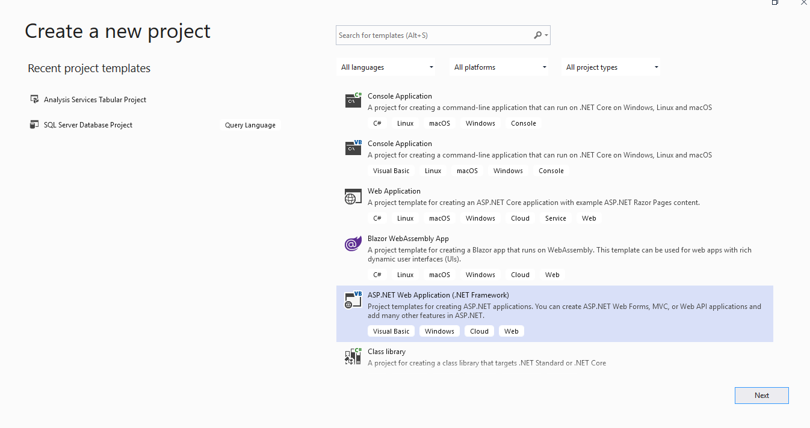

**Step 1**: Create a ASP.NET MVC project using C# and .NET Framework in Visual Studio 2019

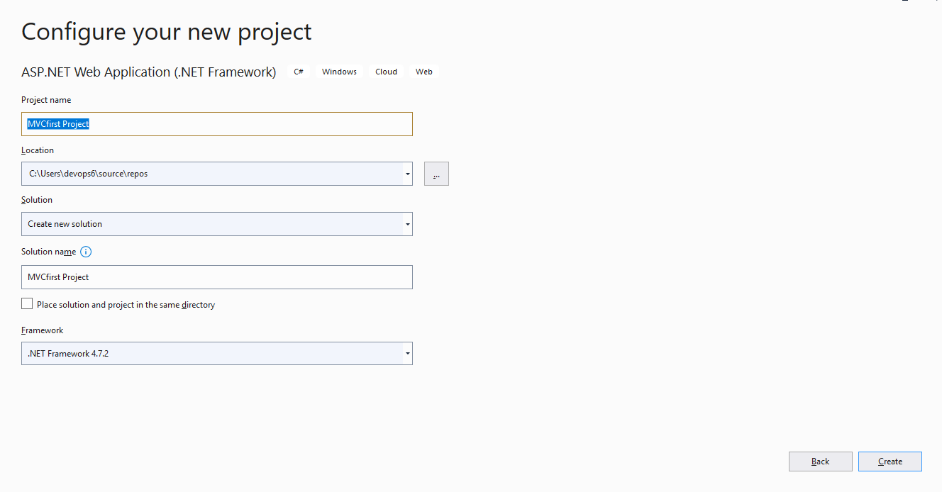

Step 2: Configuring New Project with a project name

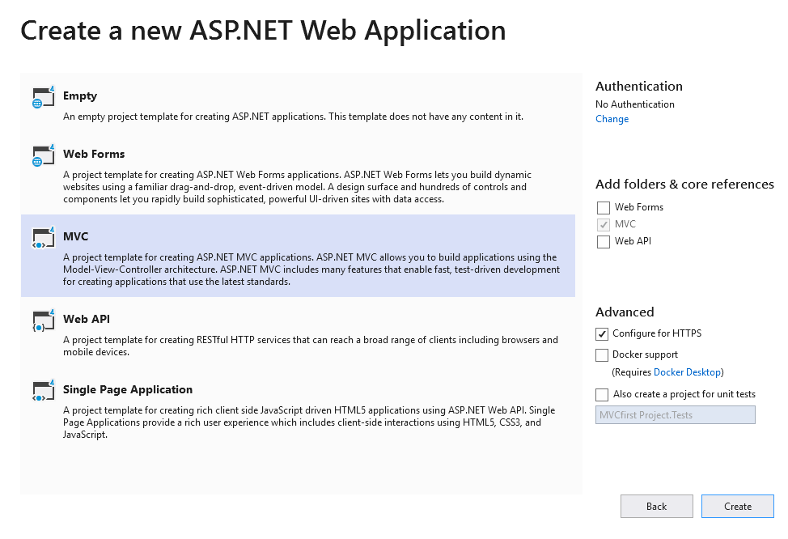

Step 3: Creating a MVC Project template for ASP.Net.mvc application

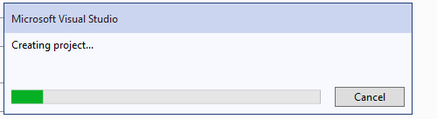

Step 4 : Creating a project in vs code editor

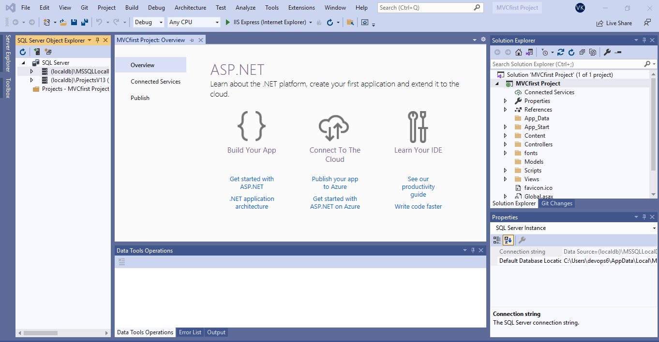

Step 5: Project Overview window

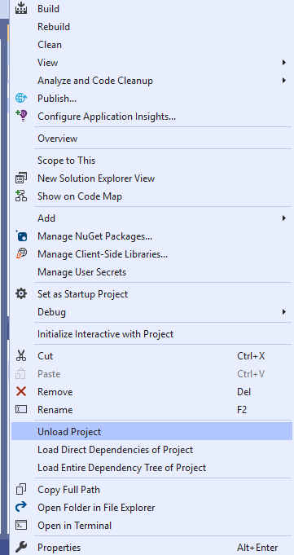

Step 6: Then got to our project and need to select Unolad Project

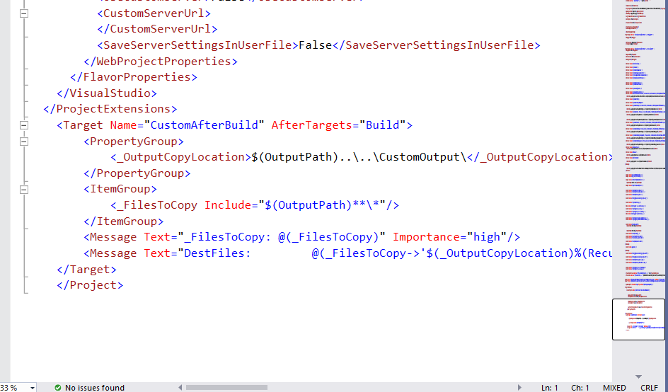

Step 7: **Copy the following targets at the end of the .csproj file before </Project>. Copied the file under target group.**

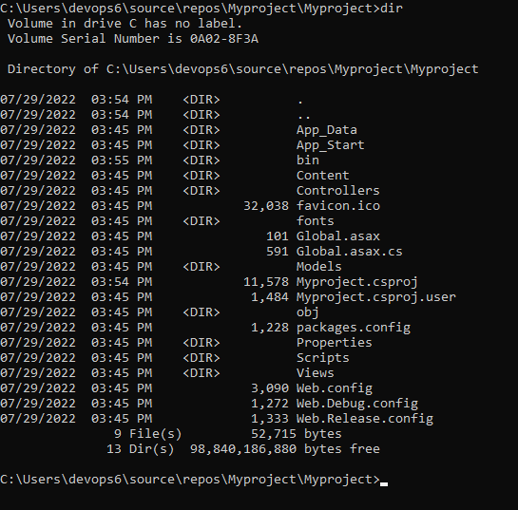

Step 8: Then need to build Myproject.csproj file

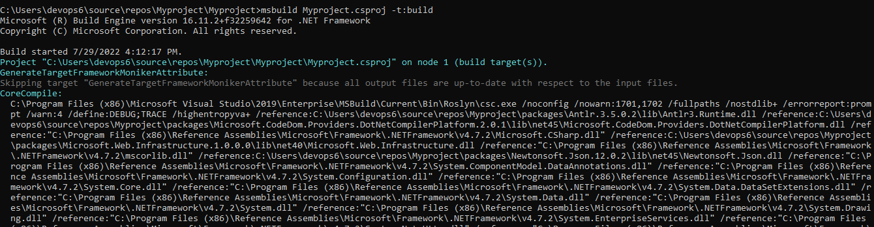

Step 9: Need to build the project by using msbuild <project name> -t:build

So that the build will be processed

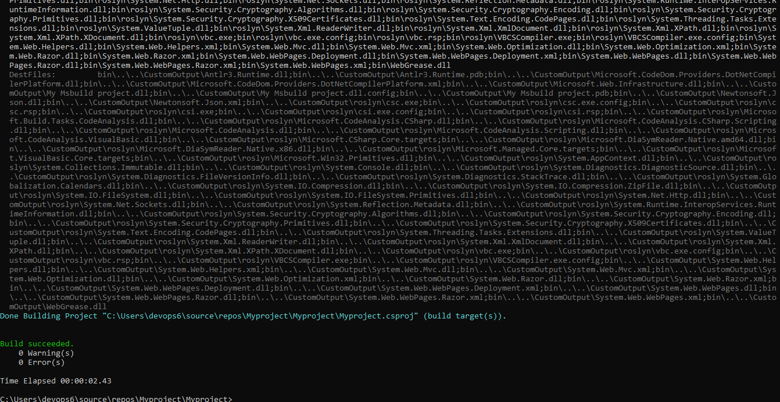

Step 10: Once the build the done if we don’t have any errors the build shows success as shown in fig

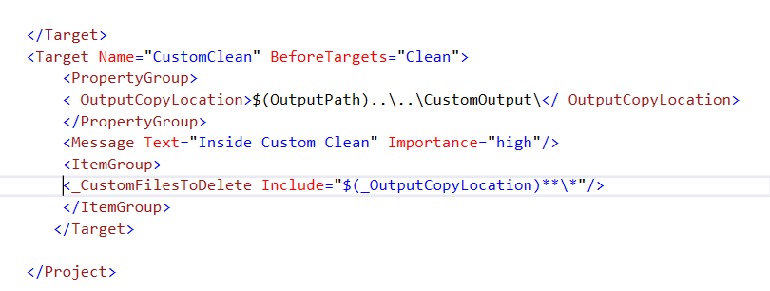

Step 11: Write a build statement which will copy all the output files to a new folder **CustomOutput**



Step 12: Then need to build Myproject.csproj file

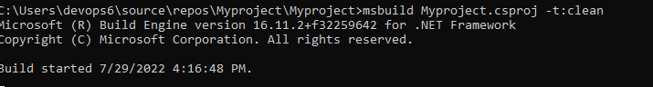

Step 13: Need to custom clean the project by using msbuild <project name> -t:clean

So that the clean will be processed

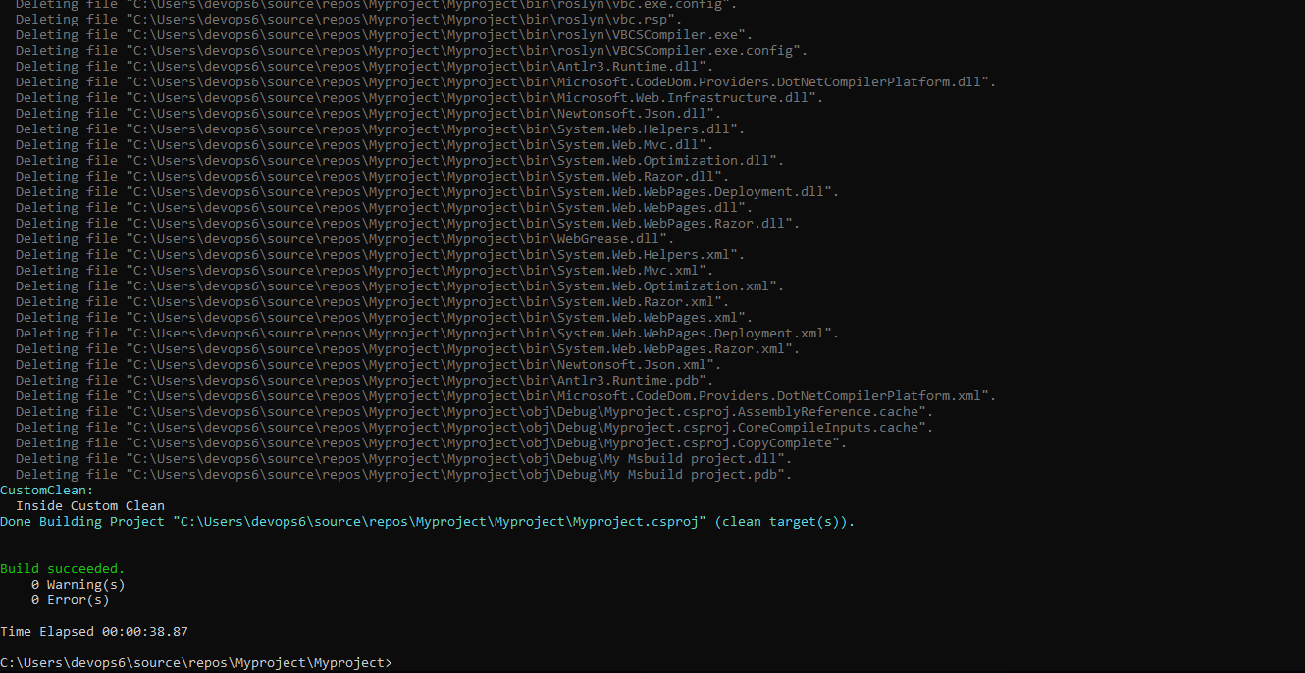

Step 14 : Once the build targrt clean is done if we don’t have any errors the build shows success as shown in fig